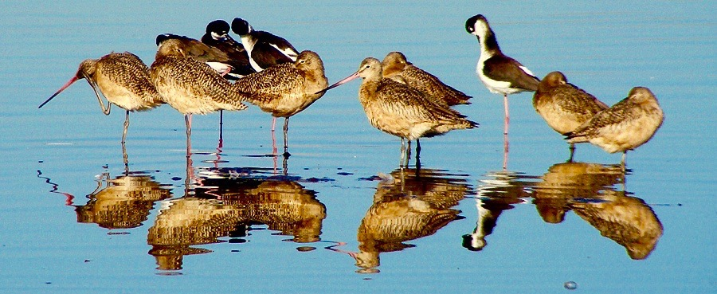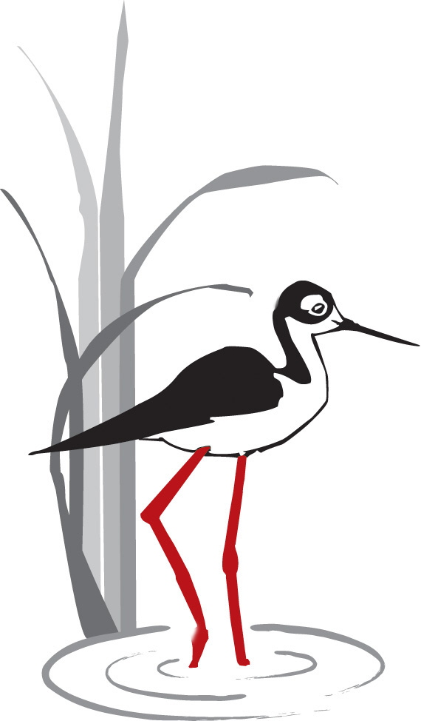

PETALUMA

WETLANDS

ALLIANCE

P.O. Box 2182, Petaluma CA 94953-2182

www.petalumawetlands.org
PWA NEWSLETTER Winter 2018

2017: PWA’s Year-in-Review Al Hesla, PWA President

The Petaluma Wetlands Alliance had a busy year in 2017. It was our second year of being an independent nonprofit organization during which we continued to update our policies and practices. With all the political turmoil, it was an especially good year to be immersed in our mission of “Education in and Stewardship of Petaluma’s Public Wetlands”. These activities nurtured our souls and benefitted the public for whom we’ve volunteered.
Here is a list of our some of our proud accomplishments of 2017:
- Trained 11 new docents. Among them were several retired school teachers, a wildlife biologist, and a physician. They will bring their experiences into the 3rd grade classrooms in addition to being involved with PWA’s other activities in the wetlands.
- Facilitated two internships: one student from Sonoma State University, and one student from Santa Rosa Junior College. We also provided activities for three Casa Grande High School students to complete their senior projects.
- Launched a newly redesigned website in March that included many new features such as a news blog, volunteer forms, and an on-line donation page. (Please check out petalumawetlands.org.)
- Conducted two successful Kids’ Events: the Christmas Bird Count for Kids in January when it rained, but the six kids who did attend were treated with sightings of two Bald Eagles; and the Spring Feather Fest for Kids in April included a rare sighting of a Least Bittern.
- Facilitated our 3rd Grade Watershed Education Program in the Spring engaging 16 schools of the Petaluma Watershed. Our Fall Education Program was impacted by the Sonoma County fire storms, but we still provided services for five schools.
- Increased the number of our community collaborations including the City of Petaluma (Water and Parks departments), Petaluma River Access Partners, Friends of the Petaluma River, United Anglers of Casa Grande High School, LandPaths, Point Blue STRAW program, and the American Association of University Women.
- Expanded our current Research activities to include Barn Owl nest box monitoring and maintenance at the Ellis Creek Water Recycling Facility. That adds to our current monthly bird surveys, rookery monitoring, and Tree Swallow and Western Bluebird nest box monitoring and maintenance.

December Bird Survey JJ Harris

Highest Count Ever plus a Semipalmated Plover
Eleven shivering birdwatchers found 77 species* on a brrr-isk morning. We were attired in gloves, scarves, parkas and (probably) long johns. We stood and watched the dawn fly-out of roughly 3,000 Red-winged Blackbirds and 1,600 gulls as the sun rose, with the water providing a mirror for the vivid orange sky. Andy LaCasse led the group. Of the 1,600 gulls we distinguished six species, including the Iceland Gull (known previously on the west coast as Thayer's Gull, a change made in July 2017 by the American Ornithological Society).

It was a big raptor day: three speedy falcons, Merlin, Peregrine and American Kestrel; Red-tailed Hawk and an especially brilliant Red-shouldered Hawk gave us a close look at its dramatic colors, deep red barred breast set off by black and white checkered wings and striped tail; five White-tailed Kites, one Sharp-shinned Hawk and several Northern Harriers. Of the harriers, we saw the silvery gray adult male, the mostly brown adult female, and the juvenile with its bright pumpkin-colored plumage. In one moment, we had the Peregrine diving on and striking a Red-tail in flight, repeatedly, while a harrier flew beneath, all in the same field of view.

I won't attempt to describe all 77 species we saw that day, but we did have a nice encounter with a Semipalmated Plover in the pond near Point Blue. This plump little plover is more often glimpsed through a spotting scope far off in the mudflats, but today it gave us a close-up. It stood right in front of us for the longest time, on the pond's edge, hunkering down and dunking its rump in the water, then popping up, over and over.

*Several watchers returned during the 48-hour period after the Friday survey and added six more species for a grand total of 83, highest count ever for a December count at Shollenberger .

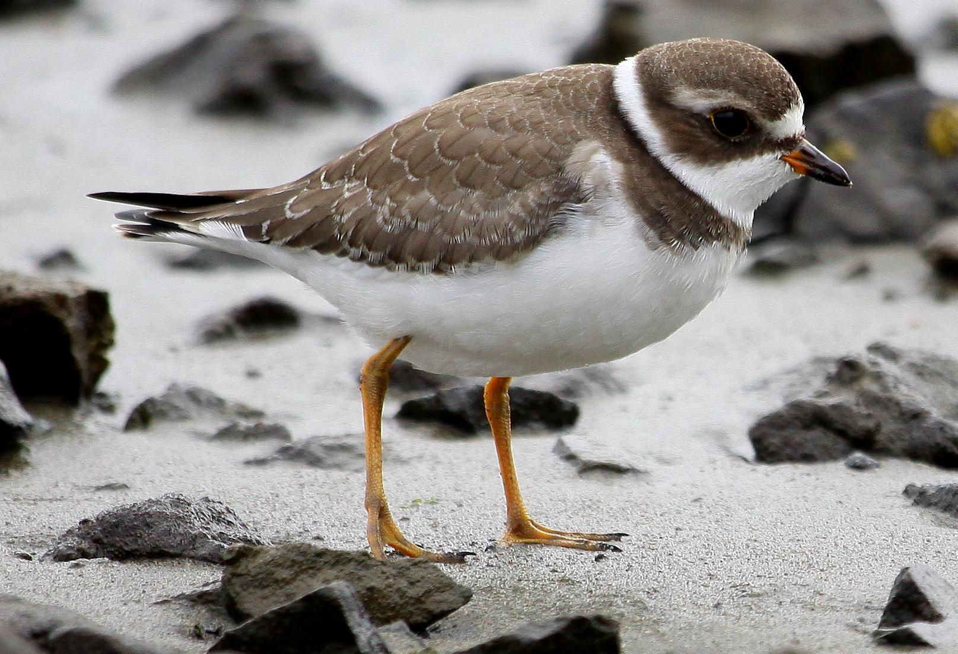
Semipalmated Plover

DOCENT DEVELOPMENT Anne Taylor

Docent Candidates Start Training

Five (maybe six) docent candidates started their training on Thursday, January 11, at the Petaluma Community Center. After welcome and introductions, PWA President Al Hesla told them about the development of Shollenberger Park and the history of PWA. John Shribbs led a discussion of wetlands biology (movement of water, food web, and many other topics). Next up is a visit to Shollenberger Park for a nature walk. In future classes they will learn about all the different activities that docents do and then concentrate on the School Program. The last regular session will be February 22 when all docents are invited to come and meet the new docents.

Save the Dates
February 22 at 9 pm at the Lucchesi Center. Meet our new docents at the last training session.
March 14, at 7 pm at the Petaluma Public Library. Docent Suzanne Clarke will speak about “Monarchs and Milkweed”.

Opportunities and Challenges Helen Heal

When does a challenge become an opportunity?
For several years, we have been challenged to update our curriculum and materials to align with changing science standards and curriculum in the schools. This year, we rounded up some of the abundant talent we have in our school docents and set to work. We have reviewed each of our activities in the classroom and the park to increase student engagement and inquiry. Docents who deliver each activity in the schools participated in these reviews as well as others who brought content expertise, and experience with instructional methodology to the work. At the same time, we had a remarkable opportunity to learn more about the original inhabitants the wetlands. Nick Tipon, an elder of the Graton Rancheria, has generously shared wisdom with us so we can integrate more understanding of past and current ways, knowledge, and perspectives into our curriculum. We will be working to support all new and returning docents in delivering the revised activities throughout the spring season. Challenge turns to exciting opportunities for personal and program growth!
and, speaking of the spring season.......
2017 proved an especially challenging year. For example, in the spring of 2017, we took our program into 16 classes, beginning March 13 and ending May 12. Doing 16 classes in two months, minus one week of spring break, completely fills our schedule. It leaves not one available Monday/Tuesday or Thursday/Friday for classroom/park schedule, meaning there were no available rainy day makeup dates if it rained on a Tuesday or Friday. And, of course, it rained one April Friday. But with flexibility on the part of the teacher and some creativity on the part of some of our docents, we were able to get those children to the park.
That busy spring was followed by a fall schedule disrupted by the October firestorm, although not as disrupted as the lives directly effected. Schools were closed, and four classes were postponed. We were able to reschedule one class for November; the other three were moved to the spring. The result of this is that beginning March 8 and ending May 18, we will be taking our program into 19 classes, the most we’ve ever done in one spring session. There are no open dates.
We are counting on docents to step up to this, and consider that it just gives us more opportunities to get to know the revised curriculum. We’ve faced challenges before. We can meet this one, and, with the children, keep on learning.

DOCENT ENRICHMENT Anne Taylor

Nick Tipon Speaks about the Miwok Culture in the North Bay

The Petaluma Wetlands Alliance and Petaluma Public Library presented a program about the local Miwok Culture on Monday, September 18th.

Our speaker was Nick Tipon, a member and elder of the Federated Indians of Graton Rancheria. He spoke about the local California Indians in his talk, “Learning from the Miwok Culture”. He presented a tribal point of view including historical, social, political, and research aspects.
About a week later a number of docents met with Nick at Shollenberger Park where he discussed the Miwok way of life. For example, he described the role of acorns in their diet.

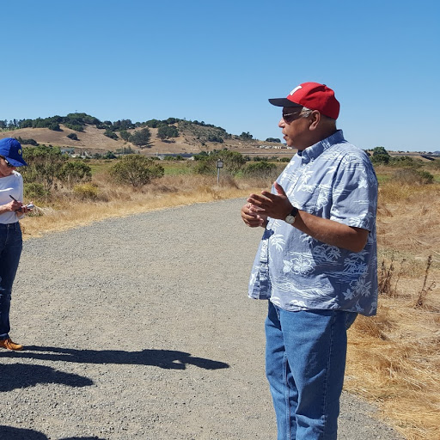
Nick Tipon

Walking along the Petaluma River with Susan Starbird

On October 18, 15 docents met Susan Starbird of Petaluma Waterways at the base of H Street. From there we walked along the River to the footbridge and across to the McNear Peninsula. At each stop along the way, Susan talked about what is there (the present) and future plans for the site. There are an amazing number of projects in progress or planned!

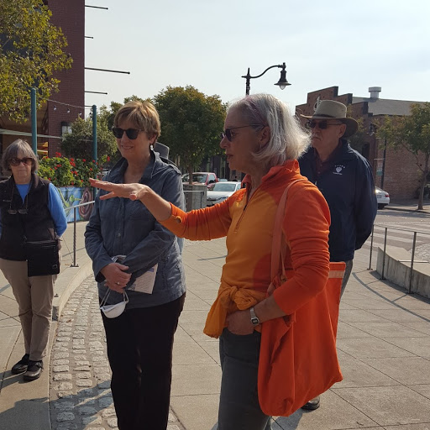Susan Starbird

Bob Dyer Tribute Calendar Nora Pearl

Going, Going, Almost Gone
Our Bob Dyer 2018 Shollenberger Park Calendars are fast disappearing. Out of the printed 150 we have only 13 left, and they are all at the Petaluma Visitors Center on Lakeville near the Smart Train stop.
Not only do you get a chance to get gorgeous photos of the birds and habitats of Shollenberger Park, a devotion of Bob’s work, you also will have a legacy of creative dedication to the park with explanations of the birds and trails in the park.

Since we are now in 2018 we are selling them, while they last, at a great discount donation price of only $10, reduced from the original price of $15.

Thanks for your support of PWA.

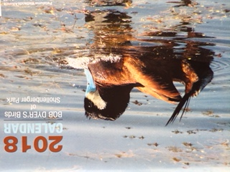

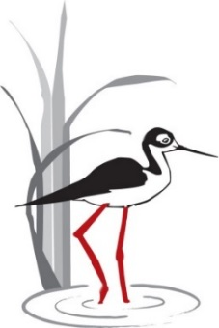

Do you love Shollenberger Park?
Do you love the Wetlands?

Become a Petaluma Wetlands Alliance DOCENT!

What do docents do?
- Tteach 3rd graders about wetlands biomes and habitats
- Llead bird walks
- Rrestore the habitats
- Conduct research on birds and other wetlands animals
- And much more!

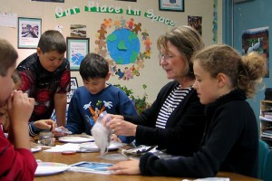

HOW CAN I BECOME A DOCENT?

Become a docent by participating in our training program and observing other docents. Training starts January 11, 2018, continuing for 7 consecutive Thursdays.

To sign up, go to:

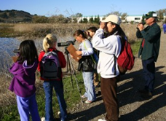http://petalumawetlands.org/docent-program/

More info: email: Akt1208@bellsouth.net

or call: 707-774-6586

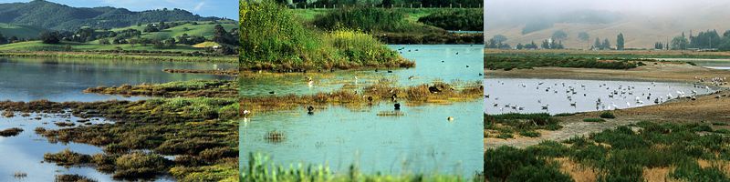

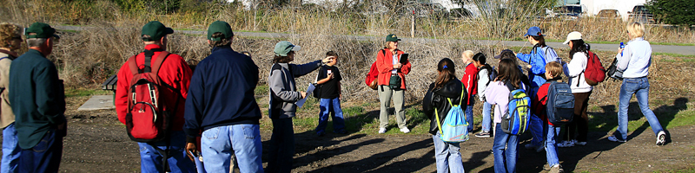

PWA Board of Directors

Al Hesla | President
Boyce Quinn | Vice President
Jerry Taylor | Treasurer
Susan Kraemer | Secretary
Anne Taylor | Docent Development
Open | Publicity & Marketing
Helen Heal | Program in the Schools
John Shribbs | Electronic Media
Mary Edith Moore | Restoration/Maintenance
Nora Lee Pearl | Historian/Librarian/Archivist
Len Nelson | Research
Kathy Cherrstrom | Membership
Join Petaluma Wetlands Alliance – “Education and Stewardship”
Please support our free 3rd grade education program for all schools in Petaluma, free public walks and presentations, monthly bird counts, bird research, and the preservation of Shollenberger Park and Allman Marsh.

I would like to join PWA:
____$25 Individual _____$40 Family Donation: $______

Make checks payable to: Petaluma Wetlands Alliance. Print this form and mail checks to:
Petaluma Wetlands Alliance, P.O. Box 2182, Petaluma CA 94953-2182

Name: _______________________________________________________________________

Home Phone: _________________________ Cell Phone: ______________________________

Address: _____________________________________________________________________

City: _________________________________State: ___________ Zip: ___________________

Email address: ________________________________________________________________

Newsletters are sent via email.
Petaluma Wetlands Alliance, Inc. is a 501(c)(3) Tax ID 81-1516247

