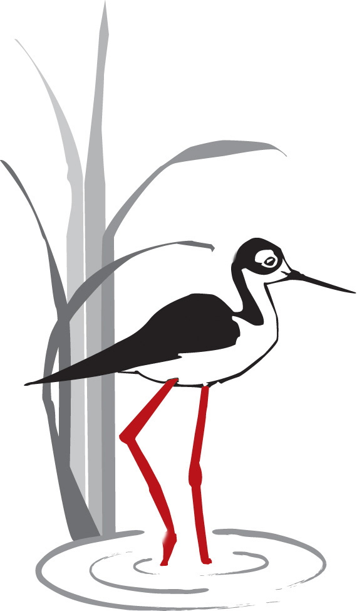
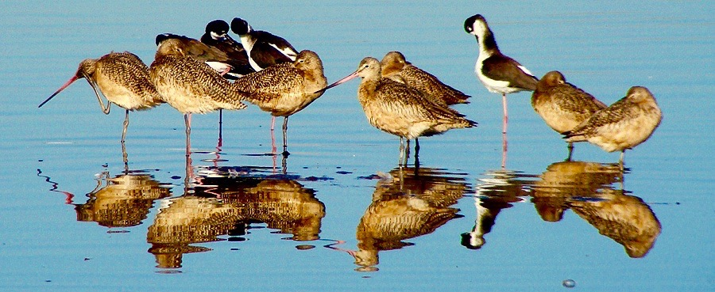

PETALUMA
WETLANDS
ALLIANCE

P.O. Box 2182, Petaluma CA 94953-2182

www.petalumawetlands.org
PWA NEWSLETTER Fall 2017

July Bird Survey JJ Harris
We survey birds not crawdads, but soon after we began our walk through Ellis Creek in July we found a large crawdad in our path, rearing up and waving its claws like he was going to take us all on. Then another, and another, plus plenty of carcasses as well. I don't know why so many were out of the water, crawling around in the grass. They are an important part of the food chain here. It brought back memories of the nine White-faced Ibis that stayed with us for a few months last year and provided such splendid viewing opportunities as well as photo ops for Bob Dyer. The ibises were very adept at catching big crawdads. Today we watched a Pied-billed Grebe choking down one that looked way too big for the grebe.
A few of us split off from the main group to walk in the creek riparian habitat, rewarded with sightings of a Wood Duck, Flicker, and Oak Titmouse. Ponds A and B cattails and tules are being bulldozed out to assist water flow. A big pile of debris remains to be burned or carted away. This could be another reason for the crawdads on land.
There are only a few ducks around now—Mallards, a few Gadwall, and one lone Ruddy Duck. Five turkey vultures perched on the fence looking like undertakers sitting in a row. Anna's Hummingbirds have successfully nested here this year. We saw several juveniles.

Tree Swallows Len Nelson

You have quite likely noticed the many bird houses in the Shollenberger/Ellis Creek wetlands.
These were built for the Tree Swallows (and occasional Western Bluebirds) that nest in our area from April through July. I have been monitoring the activity in these 28 nests for 11 years now with help from fellow PWA docents Sheryl Nadeau and Deb Sheppard. Over the course of these years, 2,325 eggs were laid; 1,961 chicks hatched from them; and 1,398 chicks lived to fledge from their nests. This represents a mortality of 28.7 percent.

Each year we make many efforts to try to improve the survival odds of the chicks, but we never know by what degree we help and how much nature and environmental issues conspire against the Tree Swallows. In any case, it is an undertaking that Sheryl, Deb, and I take on with great compassion and enthusiasm. Our goal is to make this year the one with the lowest mortality rate. We always hope that nature will provide the swallows with an abundance of flying insects to snare and feed their chicks. But, issues like mite infestations, ants, snakes, raccoons, and rodents also conspire to raise the mortality rate as does competition among the birds for these prime nesting sites.

Regular weekly visits to the houses to check on the status of the chicks can often enable us to intervene on the side of the chicks if something like a mite population is discovered. But, occasionally, we just discover that a nest has been raided by some unknown predator and all we can do is try to see how we can protect the house or its support pole to prevent future such nest invasions.

In all the previous years of monitoring the local Tree Swallows, we have never come upon a chick that was anything other than an ordinary Tree Swallow. But this year we happened upon something different. While counting the chicks in a nest at Ellis Creek, I noticed that one chick appeared to be leucistic—its feathers were lacking color pigmentation so they were quite white. See the photos below of this chick and one of its siblings for comparison. This little guy was only 6 days old when it was discovered and we monitored it until it fledged at 22 days. Currently, we are cleaning the Tree Swallow houses so they will be ready for next year’s arrivals. Please let me know if you have any questions about the Tree Swallow monitoring or want more detailed results by year.

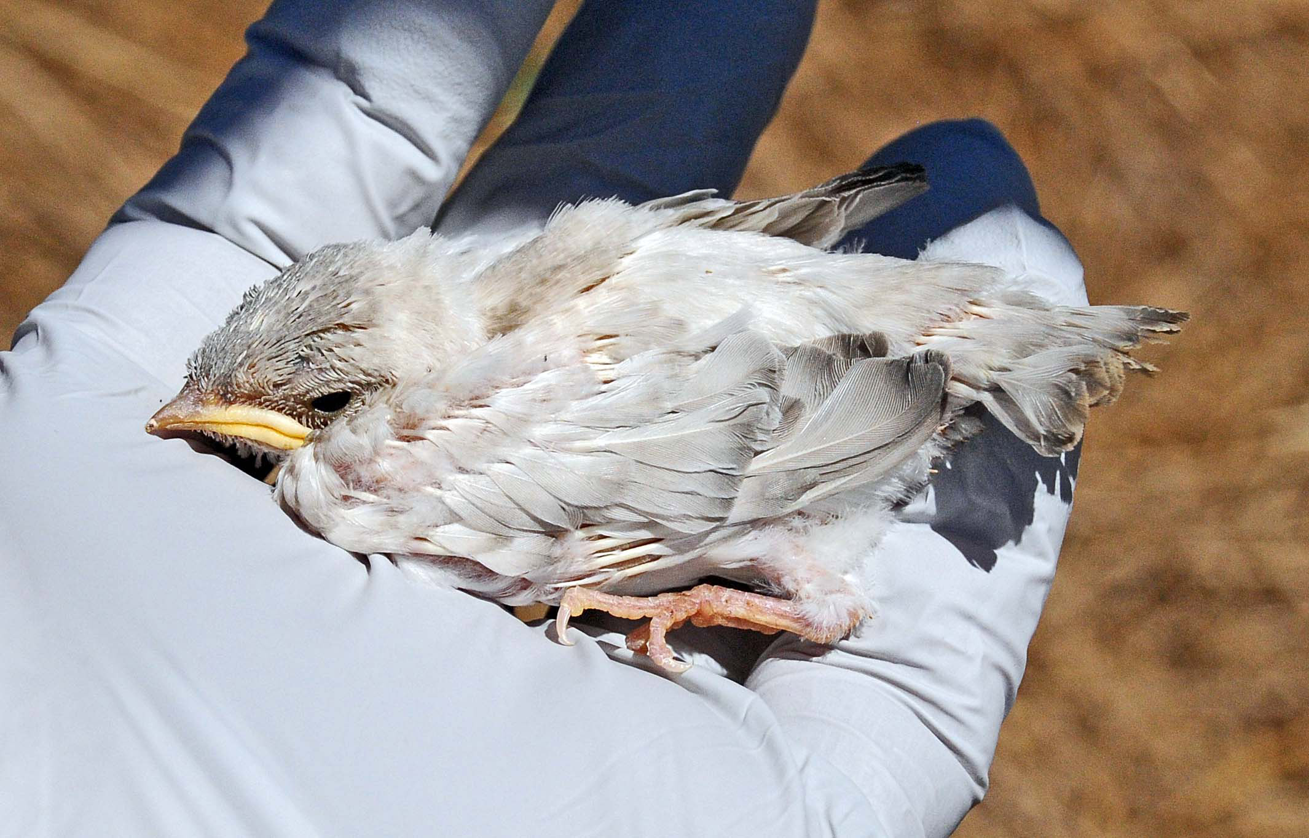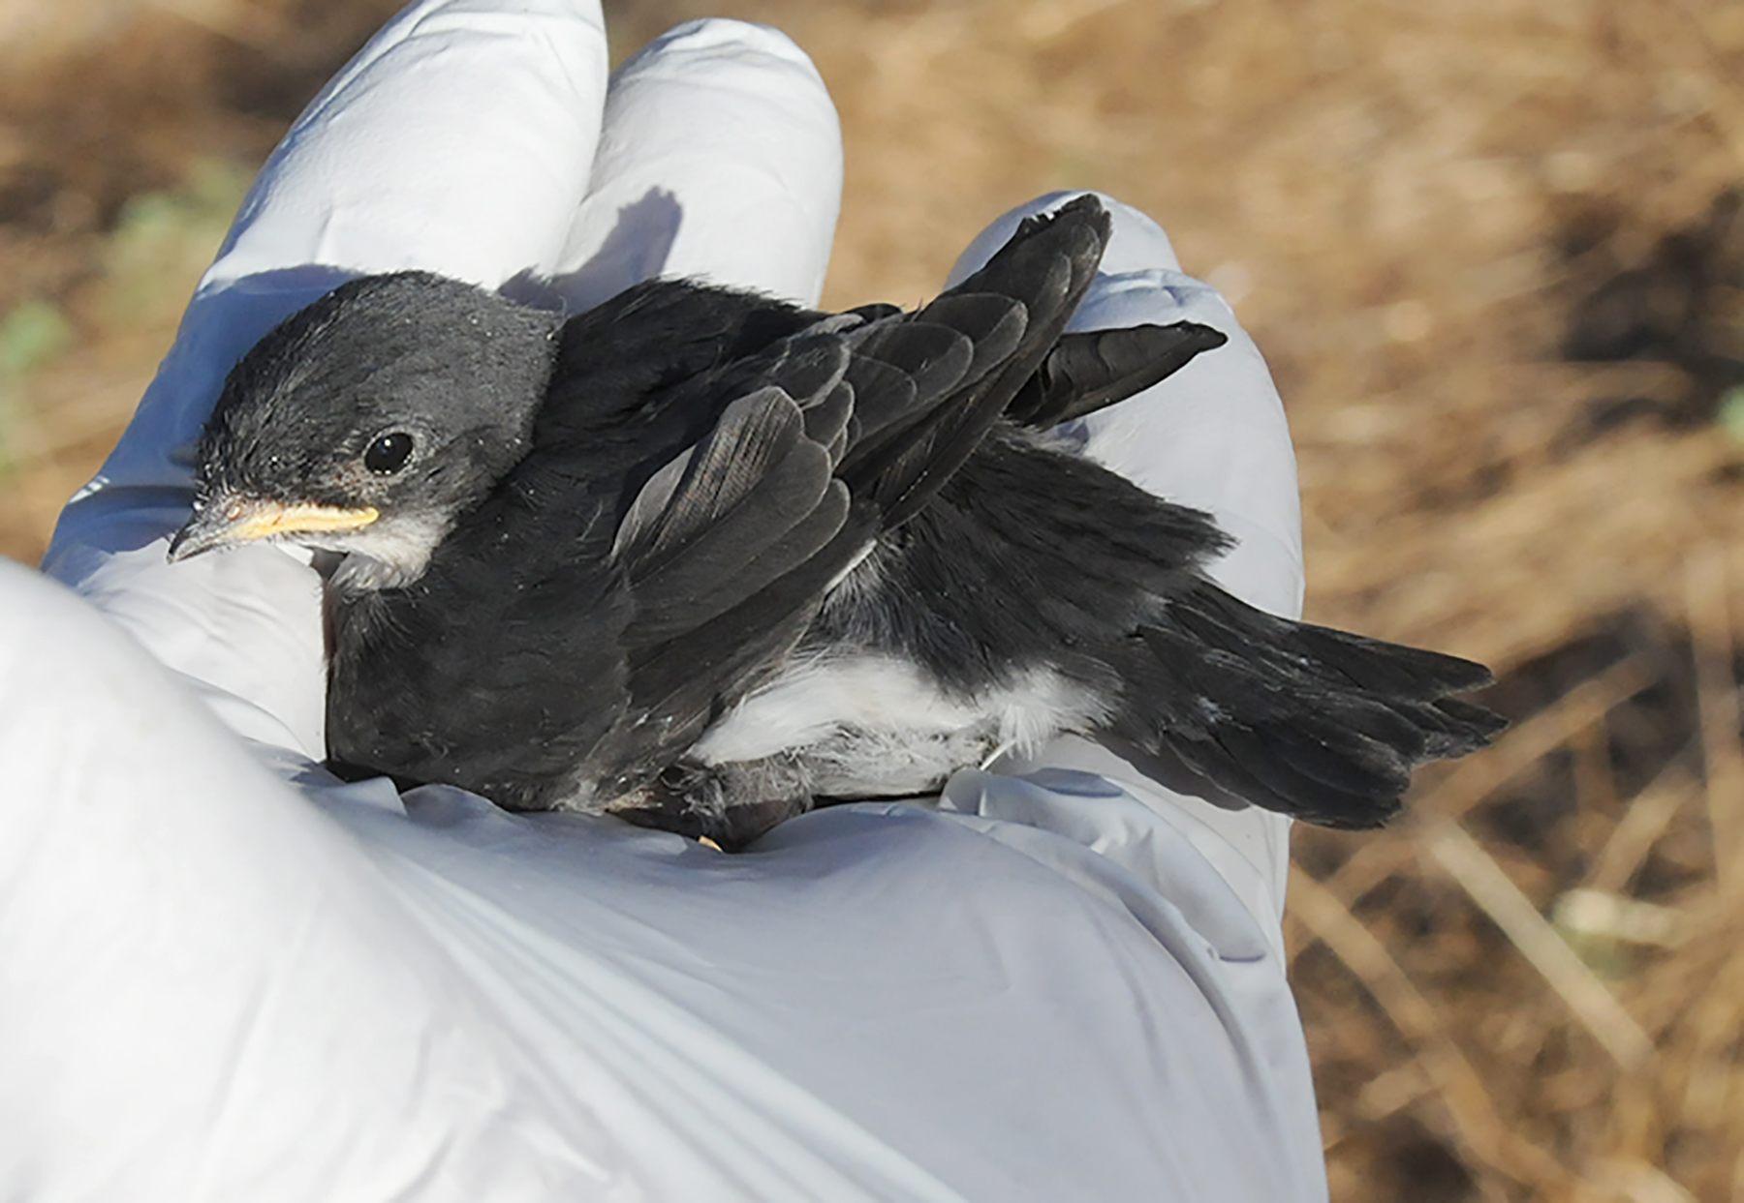
A Tribute to Bob Dyer Nora Pearl
Bob Dyer, our senior docent at Petaluma Wetlands Alliance who passed away last April, gave his bird photo collection to PWA for fund-raising purposes. We decided to take some of his brilliantly photographed local birds and showcase them in Bob Dyer's Birds of Shollenberger Park 2018 Calendar. PWA Librarian and Archivist Nora Pearl created the calendar with help from docents Peter Colasanti, Dennis Buss, Wayne Till, Sharon Mansfield, and Len Nelson. Each page of the calendar has a photo of a bird you are likely to see that month in the Petaluma Wetlands. Each photo is worthy of framing. Our purpose in creating this calendar is to honor Bob's legacy of photographs of local birds, mammals, reptiles, insects, and plants. It is available for a donation of $15 at the Petaluma Visitors Center on Lakeville at the SMART Train stop, entrance on Washington Street.

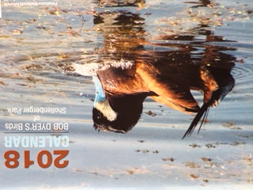

Elim Lutheran Restoration Day Mary Edith Moore

What a pleasant surprise to receive a call from Athena Labberton at Elim Lutheran, telling me that the parishioners were excited to help the Petaluma Wetlands Alliance with restoration at Shollenberger. We agreed on Sunday, September 10, noon to 4. The day, unbelievably hot, arrived and nine volunteers pulled into the Shollenberger parking lot to join Craig Cherrstrom, Kathleen Garvey, and Mary Edith Moore at the table just outside the Shollenberger gate. Kathleen gave a tool (her/his choice) to each volunteer for clearing the nonnative, invasive bristly ox-tongue along the east trail. Because of the extreme heat the volunteers were encouraged to take breaks often at the table where snacks and ice water were available. Much was accomplished: 20 bags of bristly ox-tongue were filled and emptied into the dumpster.

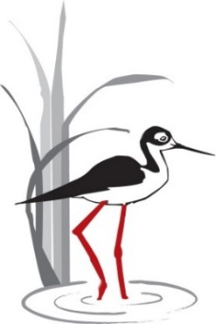

Do you love Shollenberger Park?
Do you love the Wetlands?

Become a Petaluma Wetlands Alliance DOCENT!

What do docents do?
- Tteach 3rd graders about wetlands biomes and habitats
- Llead bird walks
- Rrestore the habitats
- Conduct research on birds and other wetlands animals
- And much more!

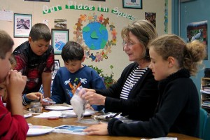

HOW CAN I BECOME A DOCENT?

Become a docent by participating in our training program and observing other docents. Training starts January 11, 2018, continuing for 7 consecutive Thursdays.

To sign up, go to:

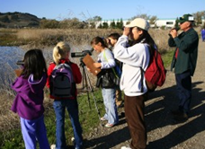
http://petalumawetlands.org/docent-program/

More info: email: Akt1208@bellsouth.net

or call: 707-774-6586

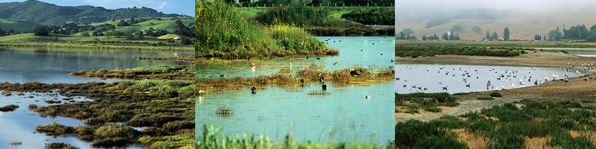

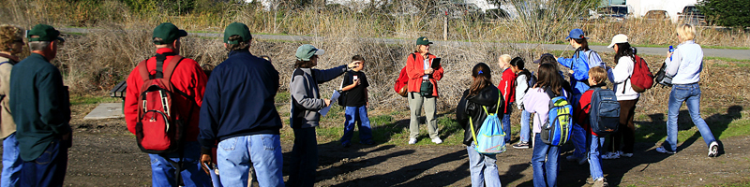

PWA Board of Directors

Al Hesla | President
Boyce Quinn | Vice President
Open | Past President
Jerry Taylor | Treasurer
Susan Kraemer | Secretary
Anne Taylor | Docent Development
Open | Publicity & Marketing
Helen Heal | Program in the Schools
John Shribbs | Electronic Media
Mary Edith Moore | Restoration/Maintenance
Nora Lee Pearl | Historian/Librarian/Archivist
Len Nelson | Research
Kathy Cherrstrom | Membership
Join Petaluma Wetlands Alliance – “Education and Stewardship”
Please support our free 3rd grade education program for all schools in Petaluma, free public walks and presentations, monthly bird counts, bird research, and the preservation of Shollenberger Park and Allman Marsh.

I would like to join PWA:
____$25 Individual _____$40 Family Donation: $______

Make checks payable to: Petaluma Wetlands Alliance. Print this form and mail checks to:
Petaluma Wetlands Alliance, P.O. Box 2182, Petaluma CA 94953-2182

Name: _______________________________________________________________________

Home Phone: _________________________ Cell Phone: ______________________________

Address: _____________________________________________________________________

City: _________________________________State: ___________ Zip: ___________________

Email address: ________________________________________________________________

Newsletters are sent via email.
Petaluma Wetlands Alliance, Inc. is a 501(c)(3) Tax ID 81-1516247

